Docker installation manual:

1. Download Image form: <https://hub.docker.com/>

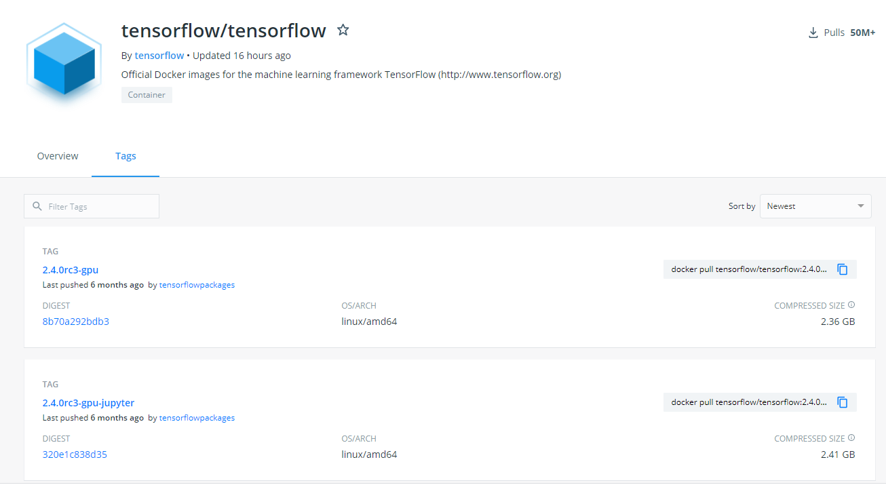

Choose needed version, copy command.

Example, I choose the tensorflow 2.1: docker pull tensorflow/tensorflow:2.1.2-gpu

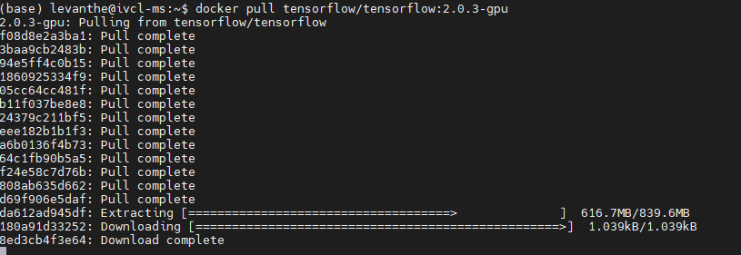

List image:

docker images



1. Create container:

$docker run --gpus all --shm-size 128gb --name ($container_name) -it (images_id)

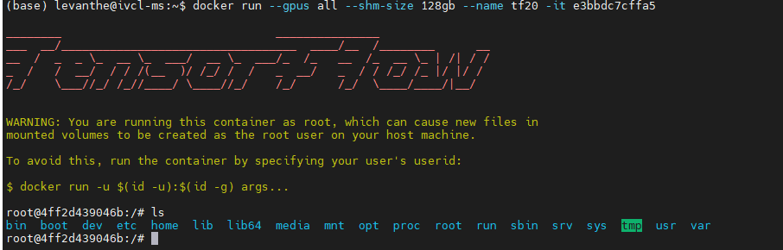

1. Install some package

apt update

apt install ffmpeg

apt install python3-opencv

apt-get install wget

apt install vim

apt-get install unzip

apt-get update

apt-get install ffmpeg libsm6 libxext6 -y

**[pip install matplotlib](https://pypi.org/project/matplotlib/)**

### [pip install ipython](https://pypi.org/project/ipython/)